**Exercise 2 - Stored Procedures:**

**Scenario 1:**

CREATE OR REPLACE PROCEDURE process_monthly_interest

AS

BEGIN

UPDATE accounts

SET balance = balance * 1.01,

lastmodified = SYSDATE

WHERE LOWER(accounttype) = 'savings';

DBMS_OUTPUT.PUT_LINE(SQL%ROWCOUNT || ' savings accounts updated.');

END;

/

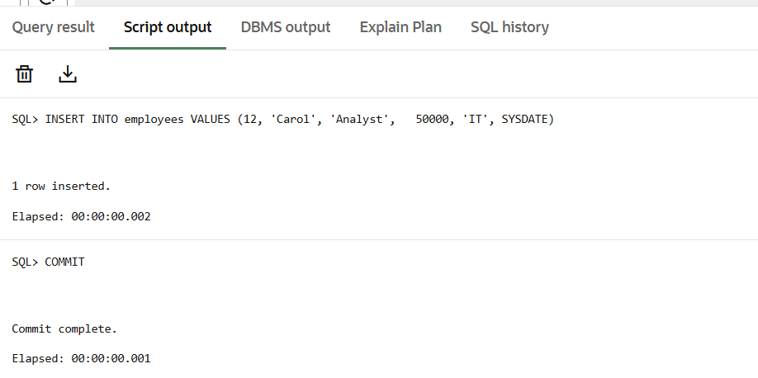

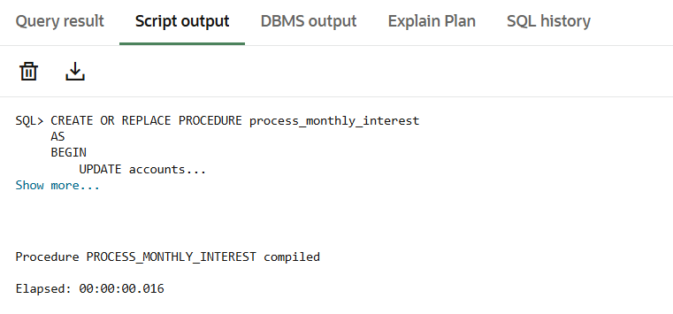

**Scenario 2:**

CREATE OR REPLACE PROCEDURE update_employee_bonus (

p_department IN VARCHAR2,

p_bonus_percent IN NUMBER -- 5 means +5 %

)

AS

BEGIN

UPDATE employees

SET salary = salary * (1 + p_bonus_percent/100)

WHERE department = p_department;

DBMS_OUTPUT.PUT_LINE(SQL%ROWCOUNT ||

' employee(s) got a '||p_bonus_percent||'% bonus in '||p_department);

END;

/

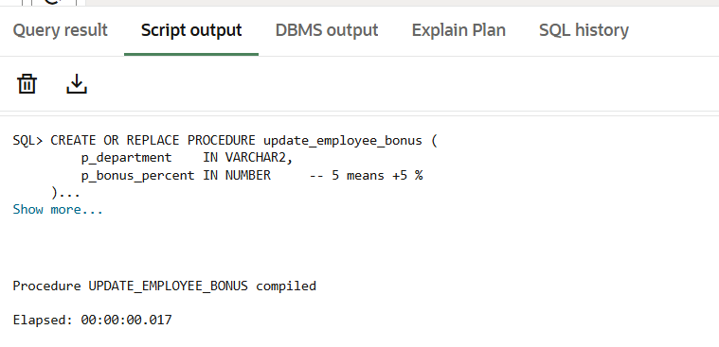

**Scenario 3:**

CREATE OR REPLACE PROCEDURE transfer_funds (

p_from_account IN NUMBER,

p_to_account IN NUMBER,

p_amount IN NUMBER

)

AS

v_balance NUMBER;

BEGIN

/* Lock both rows so nothing else changes them mid‑transfer */

SELECT balance

INTO v_balance

FROM accounts

WHERE accountid = p_from_account

FOR UPDATE;

IF v_balance < p_amount THEN

RAISE_APPLICATION_ERROR(

-20001,

'Insufficient funds in account '||p_from_account

);

END IF;

UPDATE accounts

SET balance = balance - p_amount,

lastmodified = SYSDATE

WHERE accountid = p_from_account;

UPDATE accounts

SET balance = balance + p_amount,

lastmodified = SYSDATE

WHERE accountid = p_to_account;

DBMS_OUTPUT.PUT_LINE(

'Transferred '||p_amount||

' from '||p_from_account||

' to '||p_to_account

);

END;

/

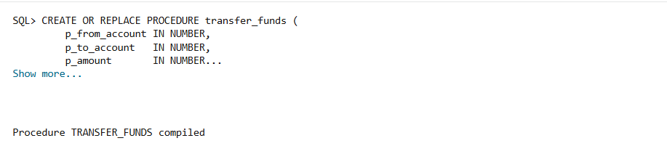

**Test / Run the Procedure:**

BEGIN

process_monthly_interest;

END;

/

BEGIN

update_employee_bonus('IT', 7);

END;

/

BEGIN

transfer_funds(101, 104, 2000);

END;

/

SELECT accountid, accounttype, balance FROM accounts ORDER BY accountid;

SELECT employeeid, department, salary FROM employees ORDER BY employeeid;

Select * from accounts;

